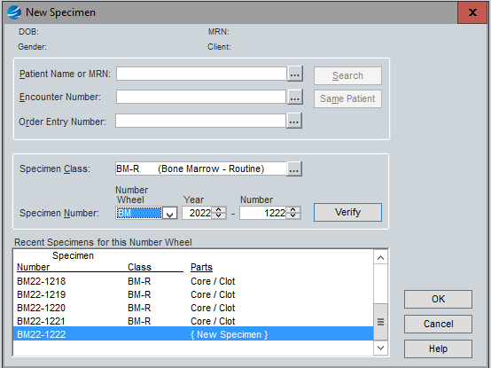
Accessioning

- If there is a bar code for the order, put cursor in the Order Entry Number field and scan the bar code and the top two fields will auto populate.
- If there is no bar code for the order, enter the MRN and choose the correct encounter and order on the requisition like other surgical cases.
  - If choosing the encounter from the list vs typing the whole thing in, note it may be at the way bottom (even though out of order date-wise) so scroll to the bottom
  - If an order number populates- confirm it is the correct order by double checking on the requisition.
- Change specimen class to BM-R and not S class.

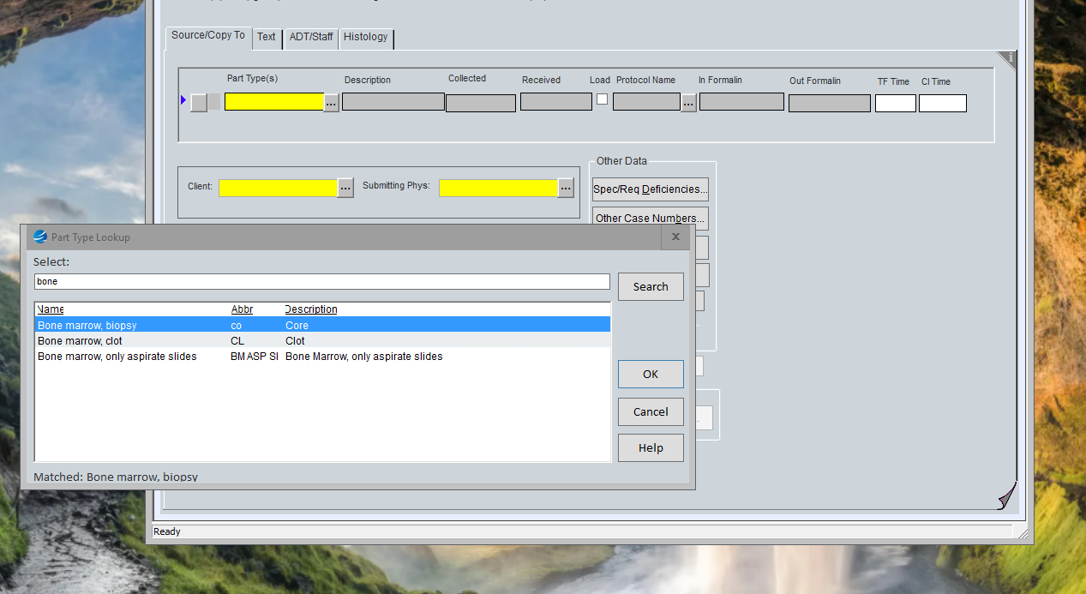
- In the first Part Type field type ‘bone’ and choose ‘Bone marrow, biopsy’ for A unless it’s a clot only.
- The description auto populates and updates the collected date. If one isn’t provided on the containers or requisition (typically handwritten at the top) default 09:00. The BM clinic orders these several days before the procedure so that date/time is not usually accurate.
- If two containers are submitted, the Bone Marrow, biopsy is A and Bone Marrow, clot is B.
- Specimen C (or last specimen in a BM case) is ‘Bone marrow, only aspirate slides’ and the description is prepopulated.
- This is where we print 8 ASP/TP slides for the smears using the part C label that can just go on the requisition.
- Part C will not be mentioned in the gross or headers.
- Confirm Client and Submitting Phys fields have been completed and are correct.
- Under the ADT/Staff tab, fill in the Pathologist on heme 1 (no service needed)
- Under the Histology tab, click Save/Engrave
- When the stickers print, put them on the requisition and the container and scan the paperwork.
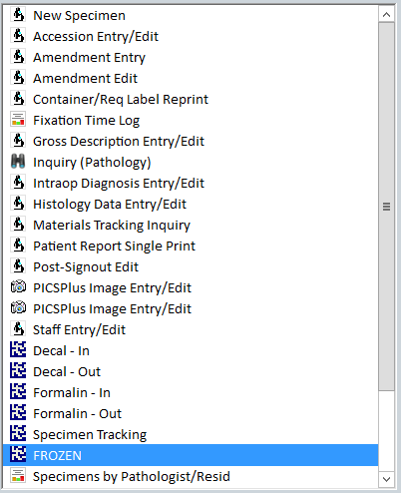
- From the Main CoPath menu click on FROZEN/ FROZEN UCH where frozen slide labels are printed and scan the C part label.
- Click on ‘Save & Label Slides’ and they will print where frozen label slides print.
- Staple these (between the top 2 stickers) to the top left-hand corner of the clean copy and put in the heme file of clean requisitions.
Headers
A) Bone marrow, core, biopsy:
-
B) Bone marrow, clot, biopsy:
-
Gross Notes
- Both can be submitted in bags or paper, but should be wrapped somehow--- most commonly in bags
- Core needs to be in formalin for an hour or two prior to decal then must be put in decal for 30 minutes.
- Use timer or alarm if needed- can batch for the end of the day—can be over decaled
- Once decaled- rinse cassettes in water and put core AND clot in big rack
- (DO NOT RUN ON BIOPSIES)
- Can split clot if too big – bisect in half and put each half in a bag

Gross templates
Received are two formalin containers both labeled “[patients name/MRN]” without additional designators.
A) Containing a hard cylindrical bone core, [ __] x 0.2 cm, which is submitted in toto following decalcification in (A1).
B) Containing a cylindrical dark red blood clot, [__diameter x __ thickness] cm, which is submitted in toto in (B1).

